**LAB 07 – PS**

**NAME - SEWMINI A D B – IT24101272**

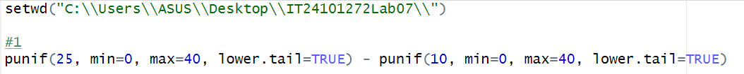



02)





03)

[i]





[ii]



